This is an open-access article under the CC BY-NC-ND license
Issue VII, November 2024
e-ISSN 2707-9481 Institute of Metallurgy and Ore Beneficiation, Satbayev University, Almaty, Kazakhstan
ISBN 978-601-80473-3-6 https://doi.org/10.31643/2024.01

Name & Last name of an author 1  Place of study or work, Country  E-mail: An email should be institutional  ORCID ID 0000-000x-xxxx-xxxx | Name & Last name of an author 2  Place of study or work, Country  E-mail: An email should be institutional  ORCID ID 0000-000x-xxxx-xxxx

The title should be in English

Abstract: The abstract and keywords should be written in English. It should be concise and factual, and state briefly the purpose of the research, the principal results and major conclusions. Also, non-standard or uncommon abbreviations should be avoided, but if essential they must be defined at their first mention in the abstract itself. Please, delete the above-mentioned information about abstract rules and provide your abstract in English between 100-200 words.
Keywords: Immediately after the abstract, provide a maximum of 5 keywords. Be sparing with abbreviations: only abbreviations firmly established in the field may be eligible.

Introduction
Ensure that the following items are present:
- The author indicates his institutional email address.
- The title is 15 words or less. Avoid abbreviations and formulae where possible.
- The article does not exceed 6,000 words.
- The Abstract has 100-200 words. It is written in a single paragraph.
- It has provided 4-5 keywords.
- The Original Article included the relevant sections: Introduction, Method (Participants, tools and procedure), Results, Discussion / Conclusions, Acknowledgement and References.
- References in the text are cited according to the APA style Reference Examples: https://apastyle.apa.org/style-grammar-guidelines/references/examples and literature should be cited for the last 5 years including the current year.

The main part of the research
This section can include information about research methods, methodology, sampling, design, experiment, results and discussions. The most important part of academic writing is the development of a clear and well-structured argument supported by evidence from credible sources. This includes conducting thorough research, critically analysing the information gathered, and presenting it logically and coherently. Additionally, proper citation and adherence to academic integrity are crucial aspects of academic writing.

Open access. This conference is fully open access under the CC BY-NC-ND license; all articles will be immediately and permanently free for everyone to read and download. You are free to share — copy and redistribute the material in any medium or format (https://creativecommons.org/licenses/by-nc-nd/4.0/).

Publication fee. To provide Open Access, this conference has a publication fee which needs to be met by the authors or their research funders. Members and reviewers of this conference committee will publish out of charge. Authors should process the payment after a conference paper has been positively reviewed by our secret reviewers.

Language. Please write your text in good English (American or British usage is accepted).

Citation in text. Please ensure that every reference cited in the text is also present in the reference list (and vice versa). When the author’s name forms part of the text, only the year of publication appears within parentheses. For instance, the technologies used for selenium extraction from middling of copper production provide roasting of selenium-containing materials and produce crude selenium (Kenzhaliyev, 2024).

Tables and Figures. Please, submit tables as editable text and not as images. Number tables and figures consecutively by their appearance in the text and place any table notes below the table body. Be sparing in the use of tables and ensure that the data presented in them do not duplicate results described elsewhere in the article. All the tables and figures should be described in the context. For example: Table 1 shows changes in microhardness and emerging structures during plasma hardening.

Table 1. The result of Regression Coefficients Reading Habits (X) towards Writing Skills (Y)

Model | Unstandardized  Coefficients |  | Standardized  Coefficients | t | Sig
 | B | Std. Error | Beta
1 (Constant)  X | 2,006  ,837 | 6,335  ,045 | ,936 | ,317  18,776 | ,753  ,000

To measure hardness, the Vickers method (HV) was used, in which a diamond tip in the shape of a tetrahedral pyramid is pressed into the surface under study, giving a more objective and accurate assessment of the hardness of metallic materials (Fig. 1).

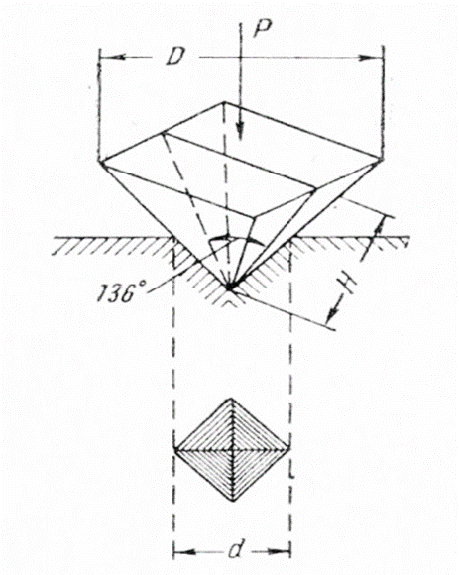

Figure 1. Scheme imprinting with a diamond pyramid

Conclusions
This part should be focused on your research result conclusions without any new ideas and any citations. Please, replace your text!

Acknowledgement. This work was supported by the Institute of Metallurgy and Ore Beneficiation JSC, Satbayev University in Almaty, the Republic of Kazakhstan / Ministry of Education and Science of the Republic of Kazakhstan, grant numbers xxxx, yyyy. The authors express their gratitude to …

Cite this article: Author, 1., Author, 2., …. (2024). Title of your article. Challenges of Science. Issue VII, pp. 20-24. https://doi.org/10.31643/2024.01

Reference. More than 100 reference examples and their corresponding in-text citations are presented in the seventh edition Publication Manual (APA style). Examples of the most common works that writers cite are provided on this page: https://apastyle.apa.org/style-grammar-guidelines/references/examples When copying references, please be careful as they may already contain errors. Use of the DOI is highly encouraged. A DOI is guaranteed never to change, so you can use it as a permanent link to any electronic article.

References

Duckworth, A. L., Quirk, A., Gallop, R., Hoyle, R. H., Kelly, D. R., & Matthews, M. D. (2019). Cognitive and noncognitive predictors of success. Proceedings of the National Academy of Sciences, USA, 116(47), 23499–23504. https://doi.org/10.1073/pnas.1910510116
Grady, J. S., Her, M., Moreno, G., Perez, C., & Yelinek, J. (2019). Emotions in storybooks: A comparison of storybooks that represent ethnic and racial groups in the United States. Psychology of Popular Media Culture, 8(3), 207–217. https://doi.org/10.1037/ppm0000185
Parks, E. L. (2022). Joining the conversation: Teaching students to think and communicate like scholars. Scholarship of Teaching and Learning in Psychology, 8(1), 70–78. https://doi.org/10.1037/stl0000193
Retnawati, H. (2017). Learning trajectory of item response theory course using multiple software. Olympiads in Informatics, 11, 123-142. https://doi.org/10.15388/ioi.2017.10
Sorokin, I.P. (1958). Izucheniye usloviy rastvoreniya zolota i serebra v tsianistykh rastvorakh pri nizkikh temperaturakh [Studying the conditions for the dissolution of gold and silver in cyanide solutions at low temperatures]. Trudy VNII-1 [Transactions of VNII-1]. Magadan Russia. № 33, 13-69 (in Russ.)

